DATABASE MANAGEMENT SYSTEM 2CS505

INNOVATIVE ASSIGNMENT

23/04/2024

TANNA OHM 22BCE213

JATAN PATEL 22BCE249

“GYM MANAGEMENT SYSTEM”

**INTRODUCTION**

The two main sections:

Backend: codes that are written in python, PHP, ASP .net to name but a few by the developer

Frontend: which is markup showed by clients or users browsers, and for doing this we should use HTML (Hyper Text Markup Language), it just shows some elements for users and doesn't run any functions. When you go to a specific URL, your request is sent to your desired server and it'll render for your HTML of the site, in fact, the server runs any server-side functions.

**Advantages of HTML:**

1. The first advantage it is widely used.
2. Every browser supports HTML language.
3. Easy to learn and use.
4. It is by default in every window so you don't need to purchase extra software.
5. You can integrate HTML with CSS, JavaScript, PHP etc.

The back-end database used in this project is MySQL

It is a language used to interrogate and process data in a relational database. Originally developed by IBM for its mainframes, SQL commands can be used to interactively work with a database or can be embedded within a script or programming language as an interface to a database. Programming extensions to SQL have turned it into a full-blown database programming language, and all major database management systems (DBMSs) support it. ANSI standardized SQL.

But most DBMSs have some proprietary enhancement, which if used, makes SQL non-standard. Moving an application from one SQL database to another sometimes requires tweaking, the age-old problem in this business!

**Advantages of MySQL:**

1. SQL Queries can be used to retrieve large amounts of records from a database quickly.

2. SQL is used to view the data without storing the data into the object

3. SQL joins two or more tables and show it as one object to user

4. SQL databases use long-established standard, which is being adopted by ANSI &amp; ISO. Non-SQL databases do not adhere to any clear standard.

5. Using standard SQL, it is easier to manage database systems without having to write substantial amount of code

**PROJECT FEATURES & OBJECTIVES**

**About the Project:**

**Gym Management System** developed using PHP is an excellent solution for gyms with a large/growing number of members, or ones serving elite clientele. This solution helps to identify the user and manage their timely memberships.

In its working, each member is issued a membership card which is valid for a fixed number of gym sessions, or for a particular period of time, or a combination of the two, totally based on the payment policy. Once the time-frame or number of sessions expire, the machine notifies the member about the payment of renewal.

Hence, the system reduces hassle and any chances of quarrels between the members and the gym management. It can also generate multiple reports like monthly, weekly, daily, session wise.

**Main features are:**

1.Gyms Management

2.Gym Members Management

3.Payment Management

4.Trainers Management

**Main Objectives are:**

1. Add different gyms.
2. Add payment areas.
3. Add members to gym.
4. Add different trainers of gym.
5. View different gyms.
6. View payment areas.
7. View members to gym.
8. View different trainers of gym.
9. Update and delete different values of gyms, payments made, gym member’s details and trainer’s information.

**DESIGN & CONNECTIVITY**

**ER DIAGRAM**

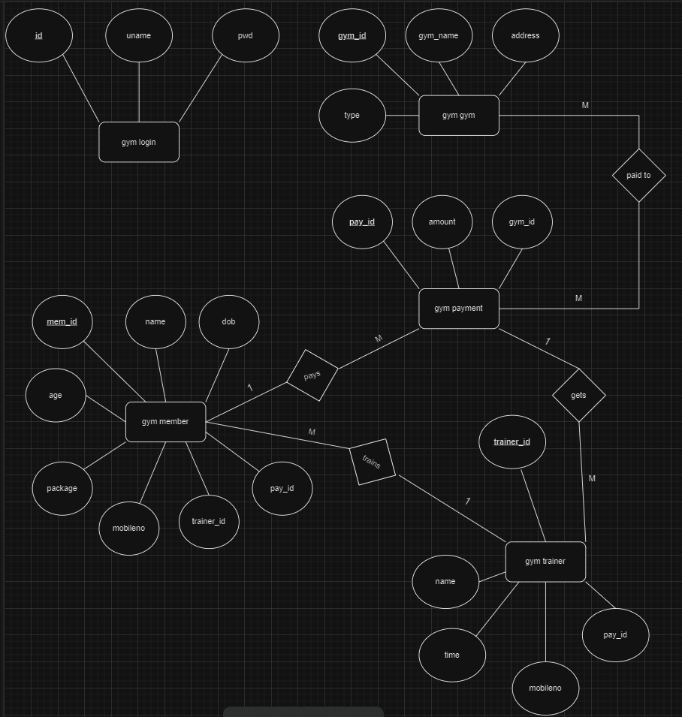

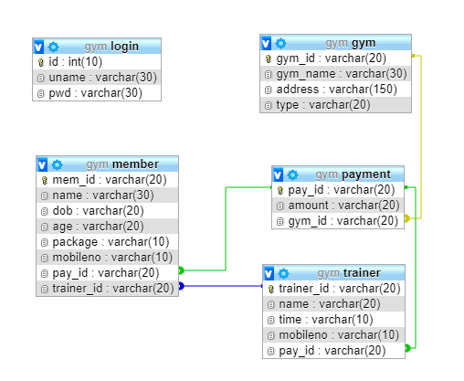

**DATABASE CONNECTIVITY**

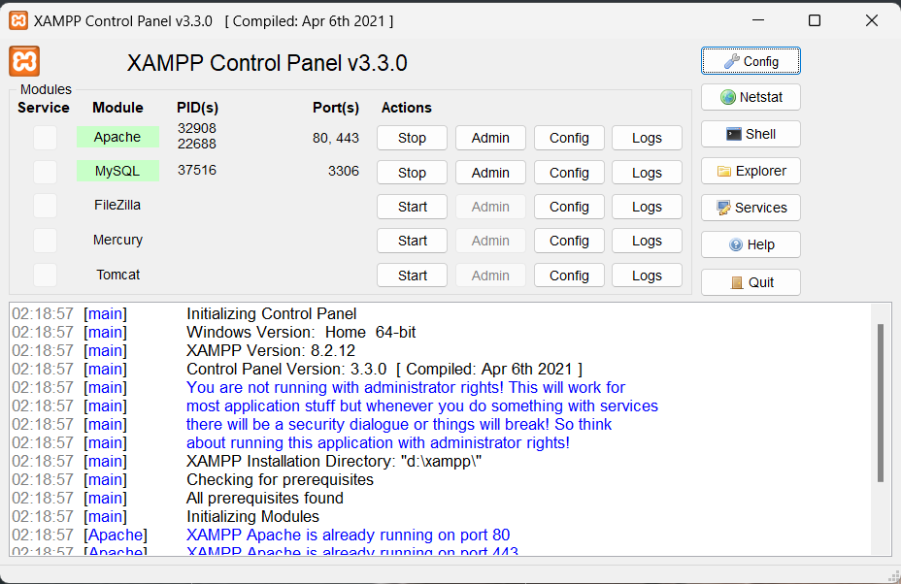

**FRONT-END DESIGN**

**HTML**

HTML is at the core of every web page, regardless the complexity of a site or number of technologies involved. It's an essential skill for any web professional. It's the starting point for anyone learning how to create content for the web. And, luckily for us, it's surprisingly easy to learn.

**CSS**

CSS stands for Cascading Style Sheets. This programming language dictates how the HTML elements of a website should actually appear on the frontend of the page.

**JavaScript**

JavaScript is a more complicated language than HTML or CSS, and it wasn't released in beta form until 1995. Nowadays, JavaScript is supported by all modern web browsers and is used on almost every site on the web for more powerful and complex functionality.

**Connectivity (front end and Back end):**

**PHP is an amazing and popular language!**

It is powerful enough to be at the core of the biggest blogging system on the web (Word Press)! It is deep enough to run the largest social network (Facebook)! It is also easy enough to be a beginner's first server side language!

* PHP is an acronym for "PHP: Hypertext Pre-processor"
* PHP is a widely-used, open source scripting language
* PHP scripts are executed on the server
* PHP is free to download and use
* PHP files can contain text, HTML, CSS, JavaScript, and PHP code
* PHP code are executed on the server, and the result is returned to the browser as plain HTML
* With PHP you are not limited to output HTML. You can output images, PDF files, and even flash movies. You can also output any text, such as XHTML and XML.

**OUTPUT SCREENSHOTS**

**ADMIN PAGE**



**ADD GYM**

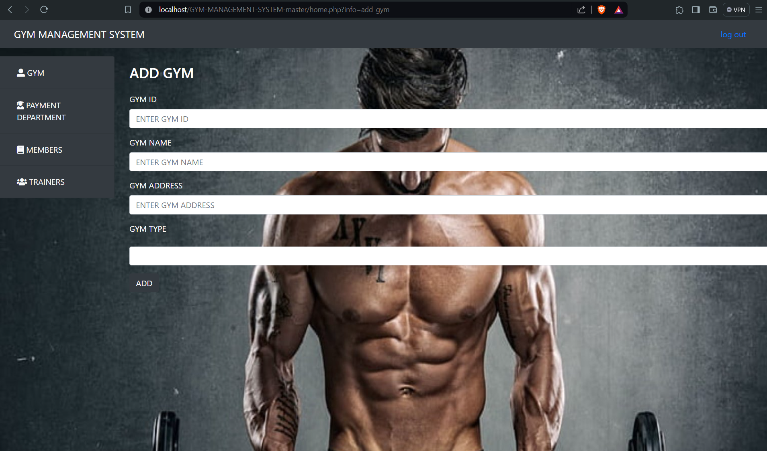

**MANAGE GYM**

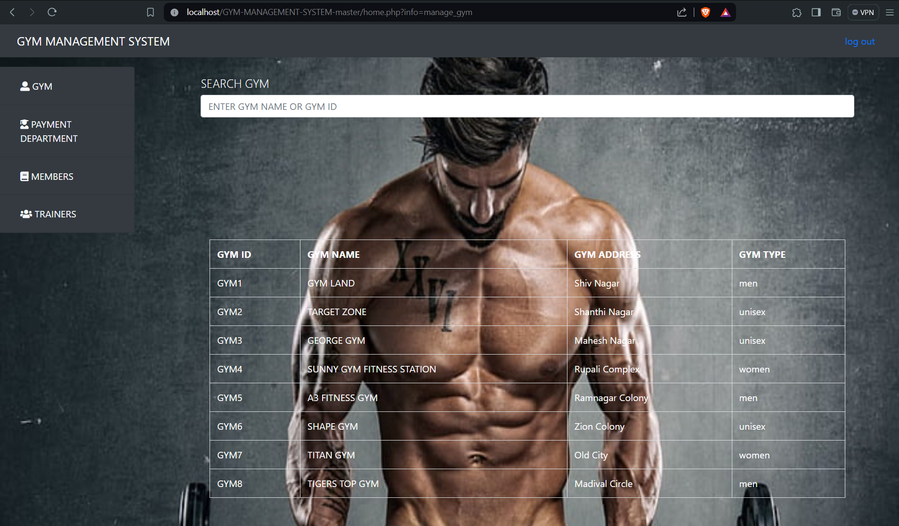

**ADD PAYMENT AREA**

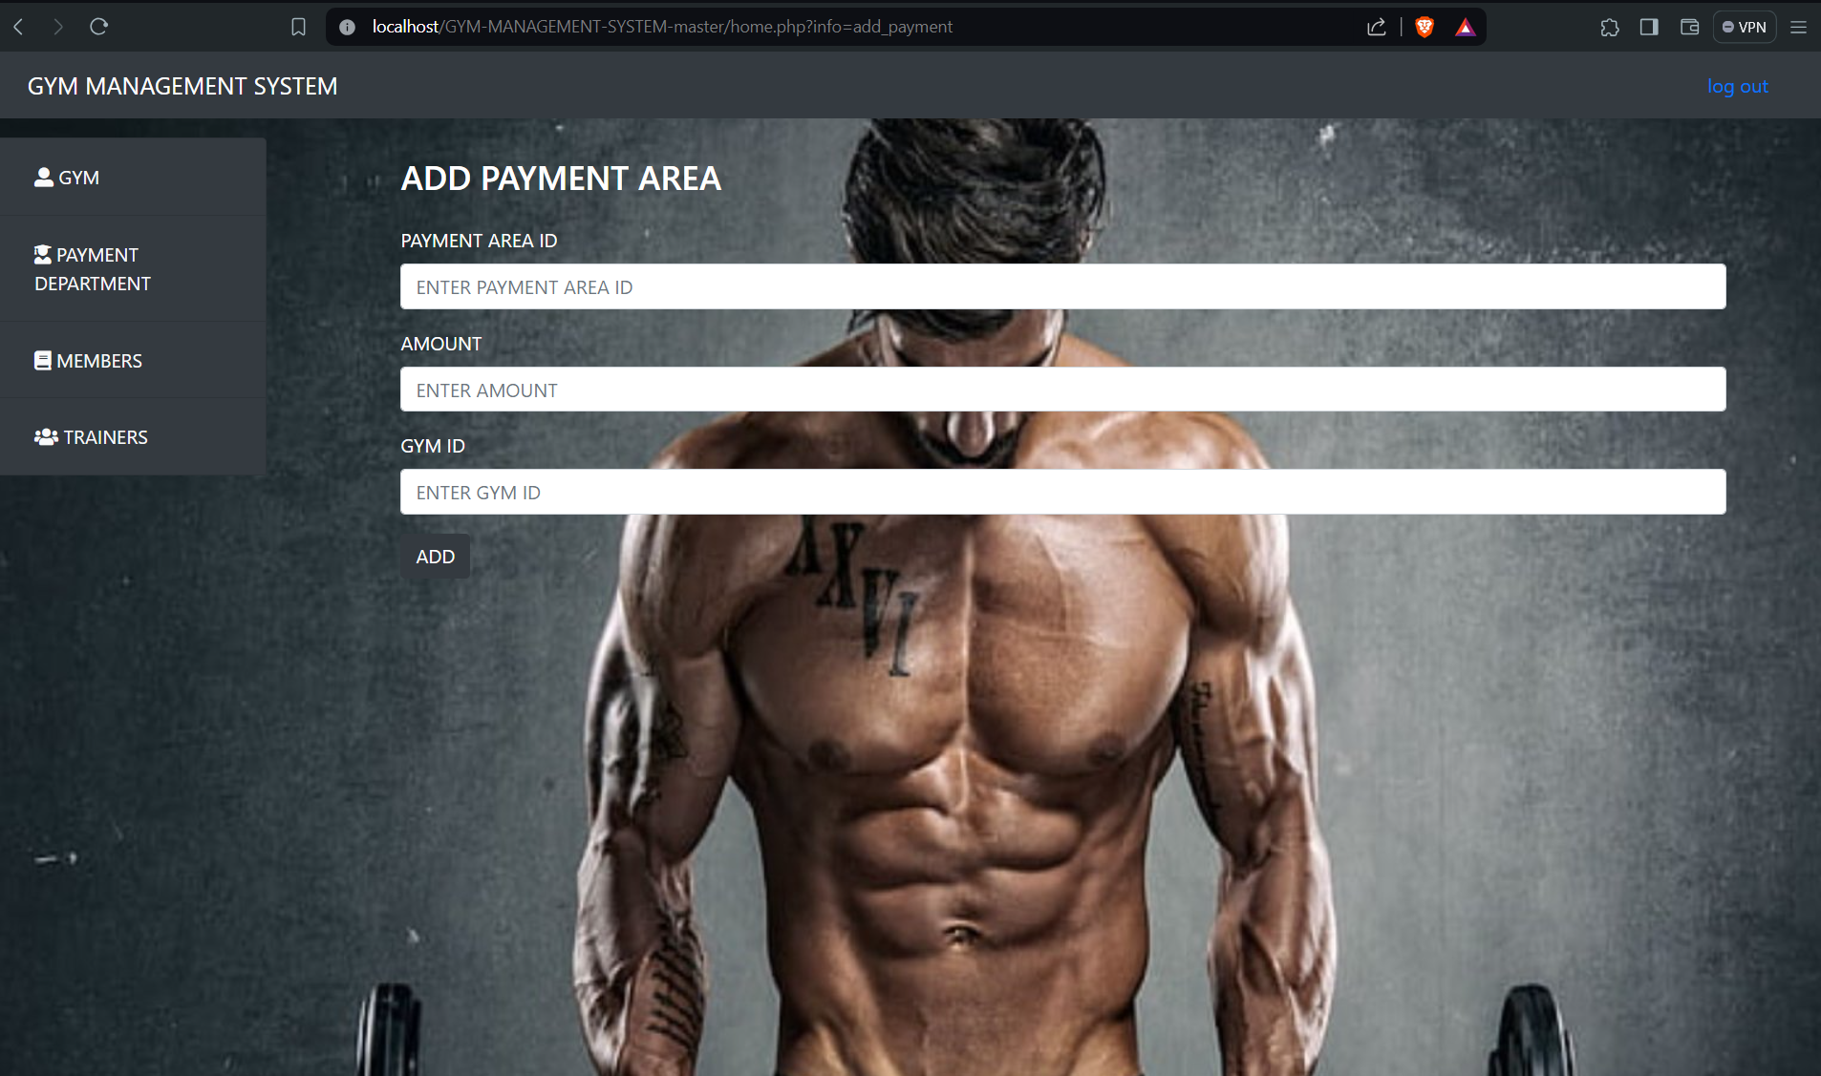

**MANAGE PAYMENT AREA**

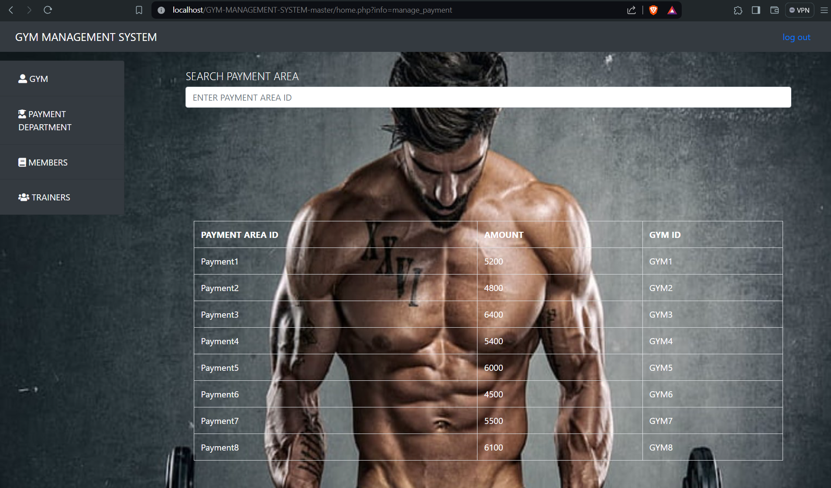

**ADD MEMBER**

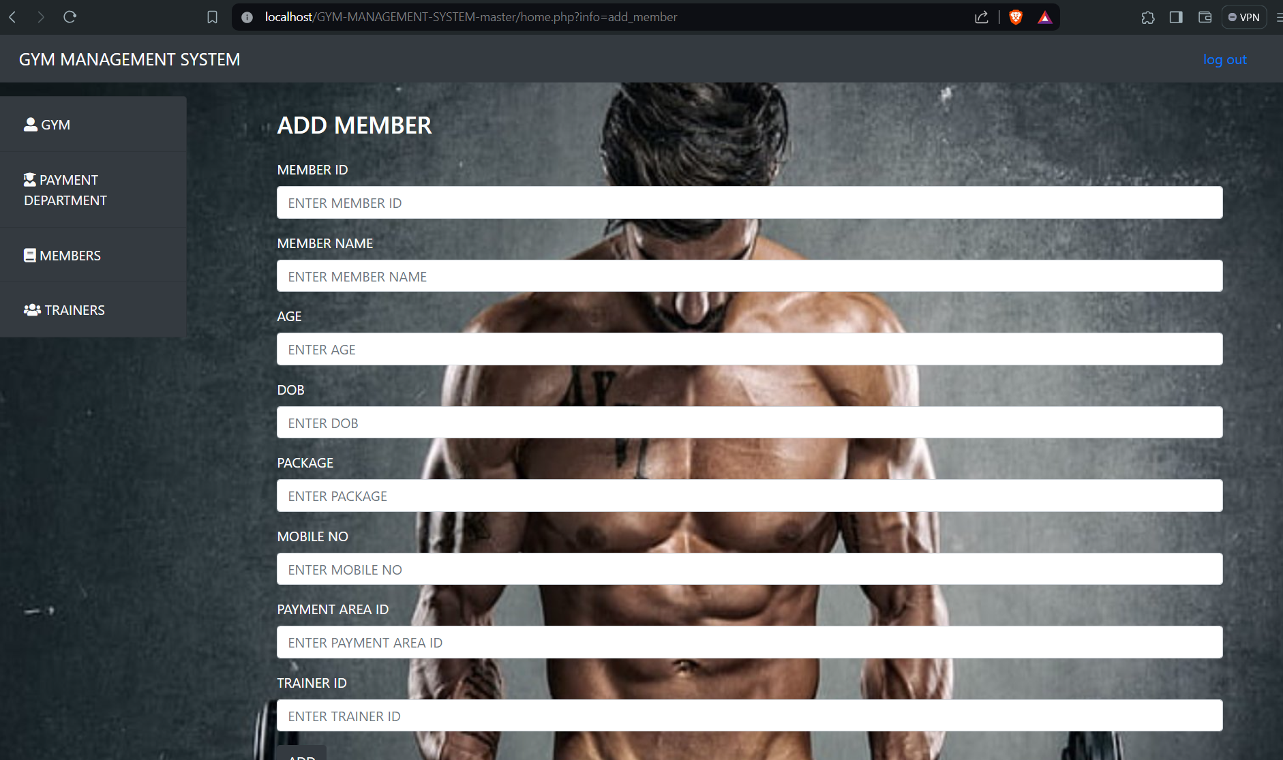

**MANAGE MEMBER**

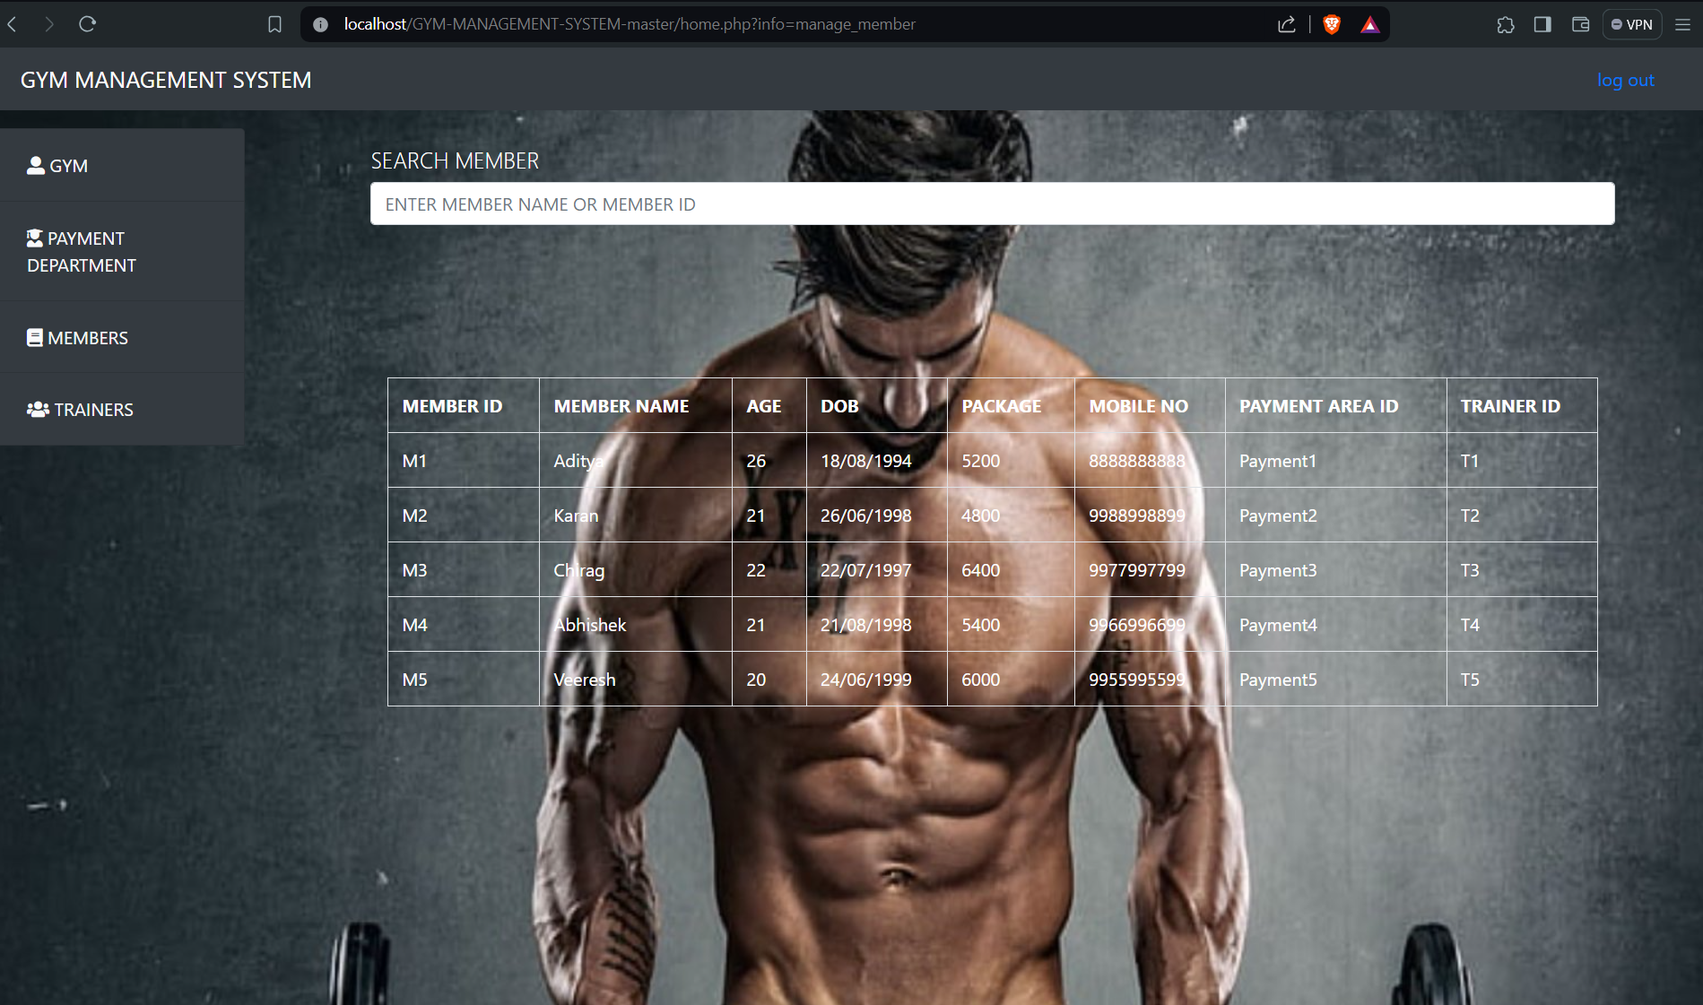

**ADD TRAINER**

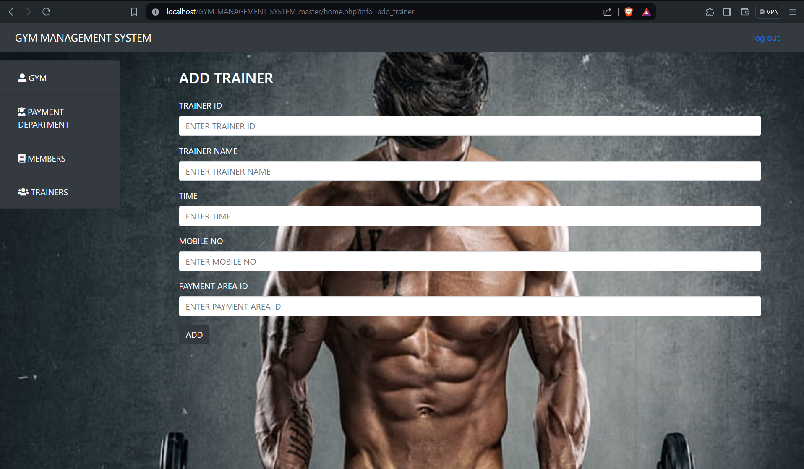

**MANAGE TRAINER**

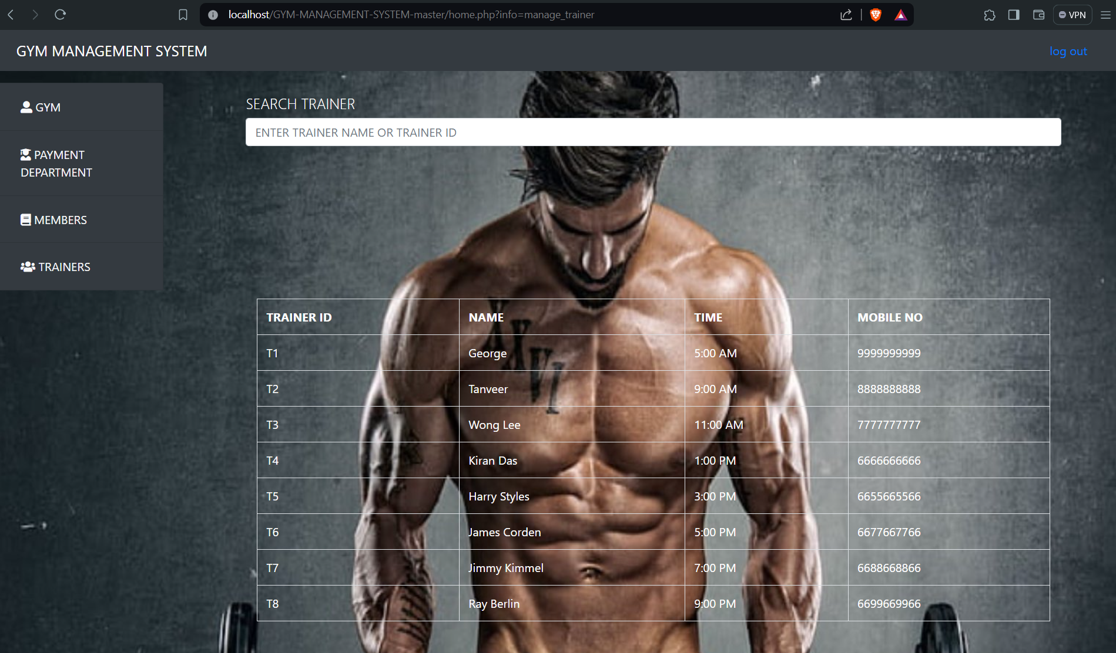

# **CONCLUSION**

While developing this project we have learnt a lot about HTML/CSS/JS/PHP/MySQL and working with database management, we have also learnt how to make the application user-friendly (easy to use and handle) by hiding the complicated parts of it from the users.

During the development process, we studied carefully and understood the criteria for making a software more demanding, we also realized the importance of maintaining a minimal margin for errors.